Always Children First: Child Safeguarding Awareness Training for Childminders
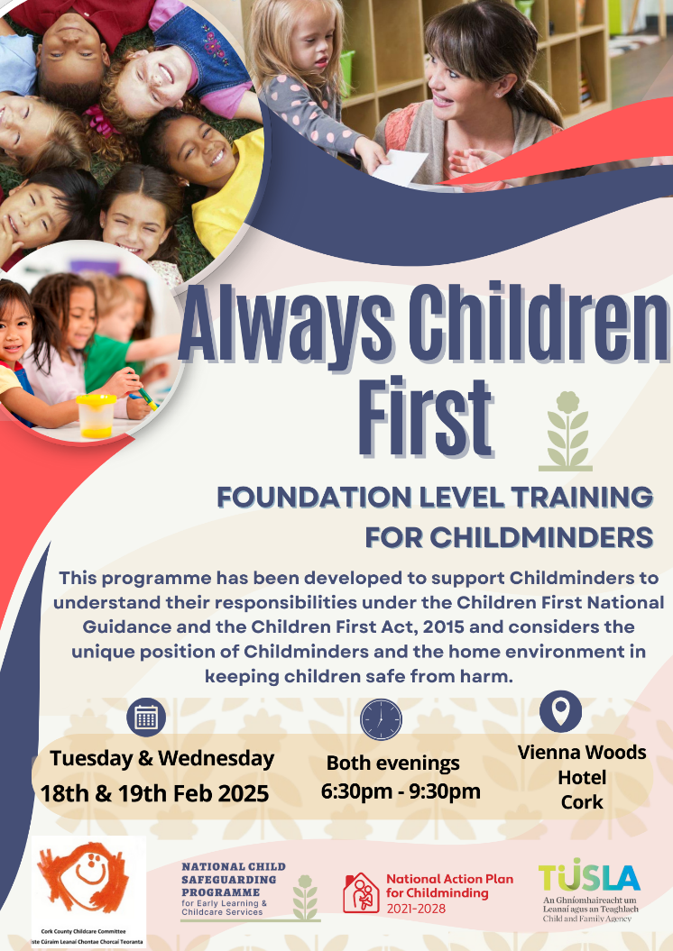
Cork CCC are delighted to offer Always Children First (ACF) Foundation Training for Childminders. This programme has been developed to support Childminders to understand their responsibilities under the Children First National Guidance and the Children First Act, 2015.
This training programme considers the unique position of Childminders and the home environment in keeping children safe from harm and will provide you with the resources and information to help you support children to grow, develop and achieve their full potential.
Prior to attending Always Children First Training, Childminders are required to complete the following eLearning Programmes:
Tusla’s Children First eLearning Programme
Tusla’s Mandated Person eLearning Programme
This training can be attended by childminders, their family members and emergency cover persons.
To book your place on this training, please contact cptraining@corkchildcare.ie for a booking form.
Further Child Safeguarding information, supports and resources can be found on the National Child Safeguarding Programme Website

